AGE OF COLONIZATION UNIT TEST STUDY GUIDE
Directions: Using your interactive notebook and resources from class, please answer each question to the best of your ability. We will go over the study guide in class on the day before the test.
Vocabulary: Define the following terms.
  - Encomienda System: legal system to organize labor; slavery
  - Triangular Trade Route trade between Europe, the Americas, and Africa
  - Globalization interaction of people around the world
  - Middle Passage voyage in which Africans were forced to go to Americas
  - Exploitation when a country takes advantage of another’s resources for their own benefit
  - “Mother Country” a country that has set up colonies in another land
  - Mercantilism when a mother country exports more than it imports; the mother country gets wealthy off the colonies
  - Inferior vs. Superior
    - Inferior: less than
    - Superior: better than
  - Indigenous native populations of an area
Causes and Effects of Colonization
- What are the three main motivations for colonization? How did each motivator encourage Conquistadors to conquer new land?
  - Gold: want money
  - Glory: want fame/power
  - God : spread religion(Christianity)
- Name the effects of colonization on both Europe and the Native people.
  - Europeans: wealthy; land; POWER
  - Native Americans: diseases and death; new resources
Colonization:
- Name the advantages and disadvantages of BOTH the Europeans(Spaniards) and the Natives in conquering of the New World.
  - Europeans
    - Advantages: better armor; iron swords; guns
    - Disadvantages: did not know the land
  - Native Americans
    - Advantages: they knew the land/environment
    - Disadvantages inferior weapons; were not immune to disease
- Who has the most power in the Encomienda System? Who has the least power? Peninsulares had the most power; slaves/labor class had the least amount of power(Natives and Africans)

Conquistadors:

- Compare and Contrast the conquests of Cortes and Pizarro.
  - Cortes: Aztec Empire; Present-day Mexico; Moctezuma
  - Pizarro: Incan Empire; Present-day Peru; Atahualpa

Slave Trade:
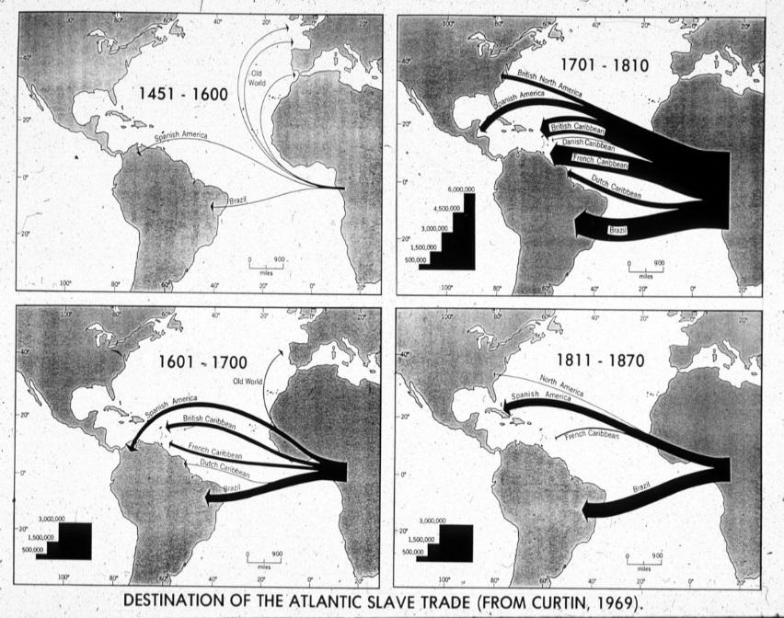
- Use the image to answer:
  - Where were most slaves sent? The Americas
  - What years saw the largest amount of slaves sent to the New World? 1701-1810

- Describe the conditions of the Middle Passage.
Unsanitary; cramped quarters; diseases; malnutrition

