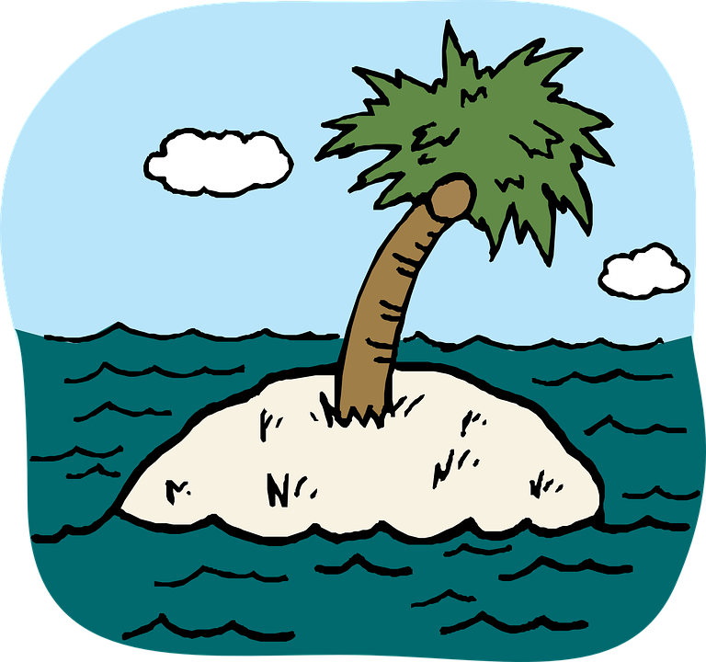
_{Survival on a Deserted Island}

You have been shipwrecked and have spent 12 months alone on a deserted island. You have decided to make a map and keep records of this experience.

Follow the steps below to create your island:
- Your teacher will provide you with a piece of paper.
- Draw your island on your paper. Any shape you wish. Be creative!
- Name your island.
- You must show the following features on your island:
• Two beaches
• Coconut palms
• A rainforest
• A shelter
• Add in 6 other features of your own.
- You must include each of these items with appropriate symbols, which then must be included and named in your legend.
- Name the surrounding bodies of water.
- Ensure you have all components of a map
- Title
- Legend or key
- Grid System
- Compass
- Scale
- Color your island; make it visually attractive and interesting.

