Revolutions Study Guide

Vocabulary:
- Revolution: a dramatic series of changes; usually with government
- Tennis Court Oath: National Assembly vowed to never disband until they had a constitution
- First, Second and Third Estates
  - First: Clergy; no taxes
  - Second: Nobility; no taxes
  - Third: Peasants; all the taxes
- Declaration of the Rights of Man: French declaration that stated the rights of all men
- The Reign of Terror: Period of French Rev. in which thousands of people were killed for “threatening” the revolution
- Coup d’etat: forceful overthrow of the government

American Revolution:
- Name the factors that led to the French and Indian War: The French and the British wanted land in the Ohio River Valley; trade disputes
- What was the outcome of the French and Indian War? Britain heavily taxed the colonists because they were in debt
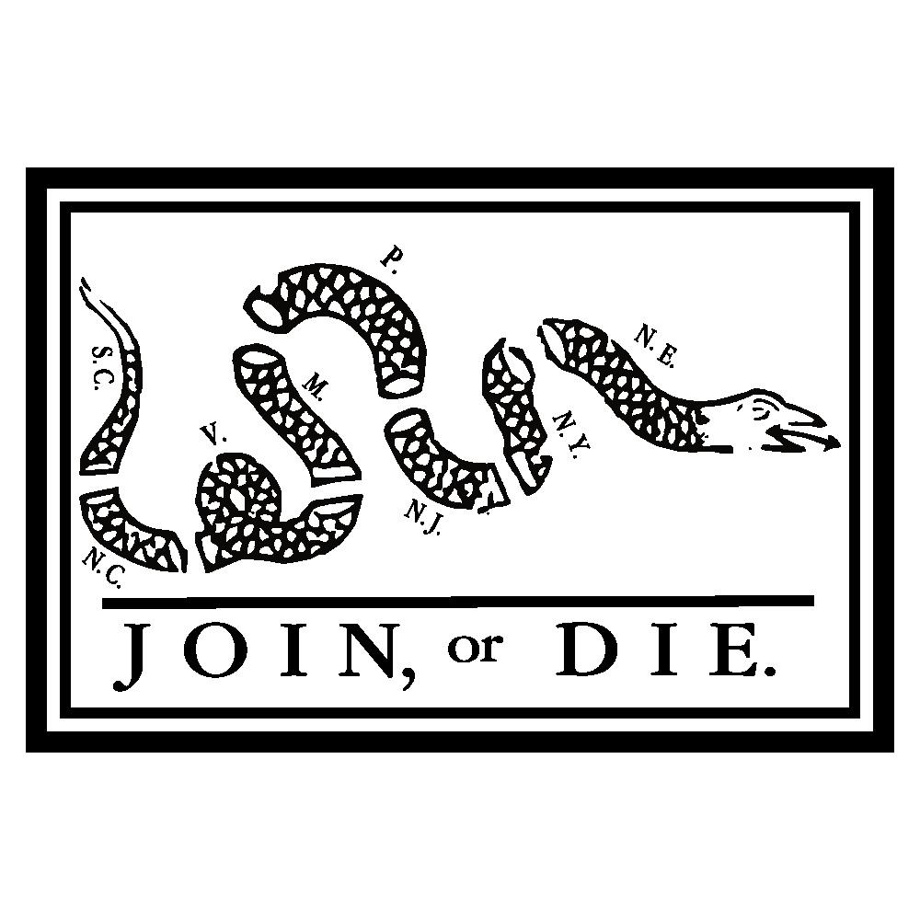
- What was the purpose of the Join or Die Cartoon? To convince the colonists to unite together against the French
- Why were colonists angry about the new taxes? NO TAXATION WITHOUT REPRESENTATION
- What was the effect of colonists boycotts on the English? English lost money
- How did Great Britain respond to the Boston Tea Party? Was their response successful? They taxed them, banned meeting, fines, troops, Intolerable Acts- PUNISHMENT; no they were not successful
- According to the Declaration of Independence, what rights does every citizen have? What happens if a government does not protect those rights? Natural rights- life, liberty, and the pursuit of happiness; Citizens have the right to overthrow the government
- What was the purpose of the Declaration of Independence? To declare independence from Great Britain

French Revolution:
What were the main differences between the First, Second and Third Estates of France?
  - First: Clergy; no taxes
  - Second: Nobility; no taxes
  - Third: Peasants; all the taxes
- Why did this result in many problems in France? Third Estate was unhappy; They could not afford anything
- What are the main causes of the French Revolution?
- Enlightenment
- American Revolution
- Economic Issues(taxes, Louis’ spending)
- Weak Leadership
- Which group created the French National Assembly? Third Estate
- What is the Tennis Court Oath? National Assembly vowed to never disband until they had a constitution
- Who was the leader of the Reign of Terror? What was the Reign of Terror? Maximillian Robespierre; Period of French Rev. in which thousands of people were killed for “threatening” the revolution
- How did Napoleon take power? How did Napoleon lose power? Coup d’etat;
  - Battle of Waterloo FAIL
  - Exiled (2x)
  - Invasion of Russia FAIL
- What are the stages of the revolution? What stage was the Reign of Terror in? What about Napoleon’s coup d’etat?
  - Moderate Phase: National Assembly; Tennis Court Oath; Storming of the Bastille
  - Radical Phase: Reign of Terror
  - Strong Leader: Napoleon

